
Manchester Stained Glass – Glass FUSING
Saturdays: May & June 2026

Time & date | Workshop | Cost
23rd May £65  Or  Contact for dates for Coasters £70.  Time: 10am-12.30pm  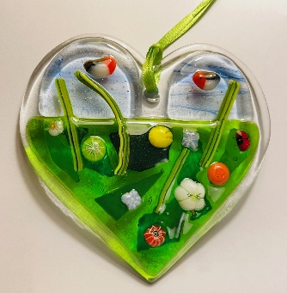  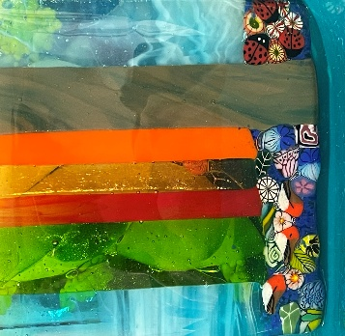  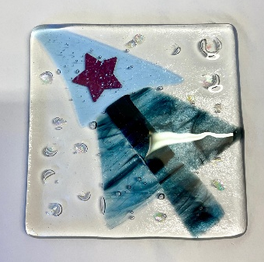 | Boutique Glass Fusing art experiences  Morning workshop  Discover the Magic of Glass Fusing, in a small group of only 4 people.  This is the art of melting colourful fragments of glass in a kiln to create beautiful, unified objects. These are small hands-on workshops, learning to cut and shape a variety of glass, from small glass sheets, to using frit, stringers, dots and little Murano pieces (like sliced up pieces of candy rock).  No experience is needed, just curiosity and creativity. Every fused piece is unique, so your creation will be truly one-of-a-kind. It’s a fun, relaxing activity for anyone who enjoys experimenting with colour and texture.  Choose between or try both:  Glass Heart workshop Saturday 23rd May 10am-12.30pm  Glass Coaster workshop – Contact for dates, two and half hour session.  Happy to run bespoke sessions for friends or family groups.  Your finished piece will be fired in the kiln and available within 1–2 weeks for collection or can be returned to you.  Small group workshop with a maximum of 4 participants  All materials included and teas/coffee and biscuits  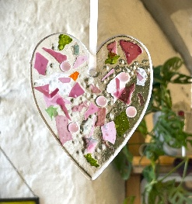 | £65.00  Or  £70.00

*NOTES
Please do ring if you would like to discuss, thank you

Manchester Stained Glass - www.manchesterstainedglass.co.uk
Glass Fusing Booking Form
Saturday Workshops May – June 2026

To book a place on a course, please read and fill out the form below. All courses are on a first come first serve basis.

Name:
Address:
Tel: Email:

Could you say where you heard about Manchester Stained Glass?

Date | Course | Fees |   Please tick
23rd May 2026  10am – 12.30pm | Boutique Glass Fusing experiences  Make a beautiful Heart decoration | £65.00
Contact for available  Dates or bespoke sessions. | Boutique Glass Fusing experiences  Create a coaster for your favourite cup | £70.00

- Venue: AWOL Studios, Hope Mill, Pollard Street, Manchester, M4 7JA Studio, third floor.
- Payment: by BACS - email for information, thank you.
- Email this form to: sharonkdoc@yahoo.co.uk
- For further information, any questions please do not hesitate to ask, I will be happy to chat.
- sharonkdoc@yahoo.co.uk Phone: Sharon 07868 172 959
- www.manchesterstainedglass.co.uk @sharon_m_campbell Instagram profile

Please read the terms and conditions below, thank you.
PLEASE do read the Terms and Conditions below, thank you
Terms and conditions:
Workshops, a refund is only provided if the Workshop is already full or if the course is cancelled my myself.
Or if cancellation takes place 5 weeks before the start of the course.
A Booking cannot be transferred to another workshop date.
I am happy for a workshop place being offered to a friend or family member who is able to fully attend the workshop.
A booking is not complete until payment is made in advance of the workshop or course starting.
Any questions please do ask.
Thank you

