
Manchester Stained Glass
SPRING Saturdays: April to June 2026
Saturday Stained glass and Copper Foiling

Time & date | Workshop | Cost
One day workshop  Saturday: 10.00am-4.00pm  18th April 2026  Or  20th June 2026  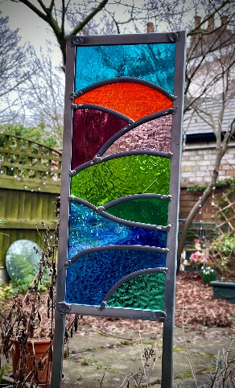 | GARDEN panel stained glass for beginners – One day workshop  Very similar to the One day stained glass beginners workshop, you will find out about and learn how to: cutting glass to a pattern, leading and soldering, using a variety of colourful and textured glass.  Making a long rectangle stained glass panel using strips of glass, lead and zinc frame, which can be pushed into the soil and displayed in your garden or in a suitable sized planter.  Pattern designs are provide, along with goggles and aprons.  Please note, this is a hands-on workshop, and we are standing whilst making and creating at a workbench with stools to sit on in-between.  *Please see notes  Small group workshop with a maximum of 3 participants  All materials included and teas/coffee and biscuits | £185
One day workshop  Saturday: 10.00am-4.30pm  30th May 2026 | Stained glass for beginners – One day workshop  During this one day workshop students find out about the techniques involved in making a stained glass panel.  You will be learning to: cut glass safely to a pattern, lead and solder a small panel together, whilst using a variety of coloured and textured glass.  By the end of the day, you will have produced a small leaded panel to take home.  Pattern designs are provided, along with goggles and aprons.  Please note, this is a hands-on workshop, and we are standing whilst making and creating at a workbench with stools to sit on in-between.  *Please see notes  Small group workshop with a maximum of 4 participants  All materials included and teas/coffee and biscuits | £175
New - TASTER Copper Foiling  4 Hour workshop  Saturday 9.30am – 1.30pm  DATES COMING | Copper Foiling – Taster 4 hour morning Workshop  The copper foiling technique, developed in the Tiffany Studios in the 1890s, is ideal for small decorative sun-catchers.  Sticky backed copper foil tape is wrapped around each piece of glass and then soldered along the seams to join the pieces together.  In this introductory workshop you will be learning to: cut glass safely to a pattern, grind glass, copper foil, solder and use a variety of coloured and textured glass.  During the workshop, you will have produced a small decorative sun-catcher.  Pattern designs are provided, along with goggles and aprons.  Please note, this is a hands-on workshop, and we are standing whilst cutting glass at a workbench with stools to sit on in-between.  *Please see notes  Small group workshop with a maximum of 4 participants  All materials included and teas/coffee and biscuits | £90
ASK ABOUT  Glass fusing experiences  Morning or afternoons  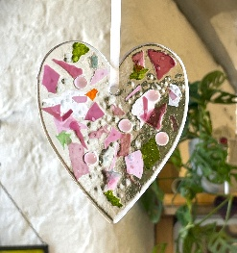  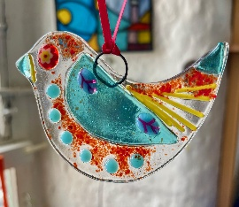 | Boutique Glass Fusing art experiences  Discover the Magic of Glass Fusing, in a small group of only 4 people.  This is the art of melting colourful fragments of glass in a kiln to create beautiful, unified objects. These are hands-on workshops, learning to shape a variety of glass, from small glass sheets, to using frit, stringers, dots and little Murano pieces (like sliced up pieces of candy rock).  No experience is needed, just curiosity and creativity. Every fused piece is unique, so your creation will be truly one-of-a-kind. It’s a fun, relaxing activity for anyone who enjoys experimenting with colour and texture.  Your finished piece will be fired in the kiln and available within 1–2 weeks.  Small group workshop with a maximum of 4 participants  All materials included and teas/coffee and biscuits

*NOTES
I am happy to help and give assistance to people on stained glass and copper foiling workshops, but a certain amount of hand dexterity is required and ability to stand at a workbench.
The processes involved require a certain amount of strength, control and time spent standing.
Because of the materials involved, stained glass and copper foiling workshops are not recommended during pregnancy. Please do ring if you would like to discuss, thank you

Manchester Stained Glass - www.manchesterstainedglass.co.uk
Booking Form SPRING Saturday Workshops April – June 2026

To book a place on a course, please read and fill out the form below. All courses are on a first come first serve basis.

Name:
Address:
Tel: Email:

Could you say where you heard about Manchester Stained Glass?

Date | Course | Fees |   Please tick
18th April 2026 | Garden Stained glass – one day workshop | £185.00
20th June 2026 | Garden Stained glass – one day workshop | £185.00
30th May 2026 | Stained glass for beginners - One day workshop | £175.00
Dates coming soon | Taster Copper Foiling workshop | £90.00
Small group bookings please ask. | Boutique Glass Fusing experiences Mornings or Afternoons | From £75.00  Per person

- Venue: AWOL Studios, Hope Mill, Pollard Street, Manchester, M4 7JA Studio, third floor, with a lift.
- Payment: by BACS - email for information, thank you.
- Email this form to: sharonkdoc@yahoo.co.uk
- For further information, any questions please do not hesitate to ask, I will be happy to chat.
- sharonkdoc@yahoo.co.uk Phone: Sharon 07868 172 959
- www.manchesterstainedglass.co.uk @sharon_m_campbell Instagram profile

PLEASE do read the Terms and Conditions below, thank you
Terms and conditions:
Workshops, a refund is only provided if the Workshop is already full or if the course is cancelled my myself.
Or if cancellation takes places more than 5 weeks before the start of the course.
A Booking cannot be transferred to another workshop date.

I am happy for a one day workshop place being offered to a friend or family member who is able to fully attend the workshop.

A booking is not complete until payment is made in advance of the workshop or course starting.
Thank you

